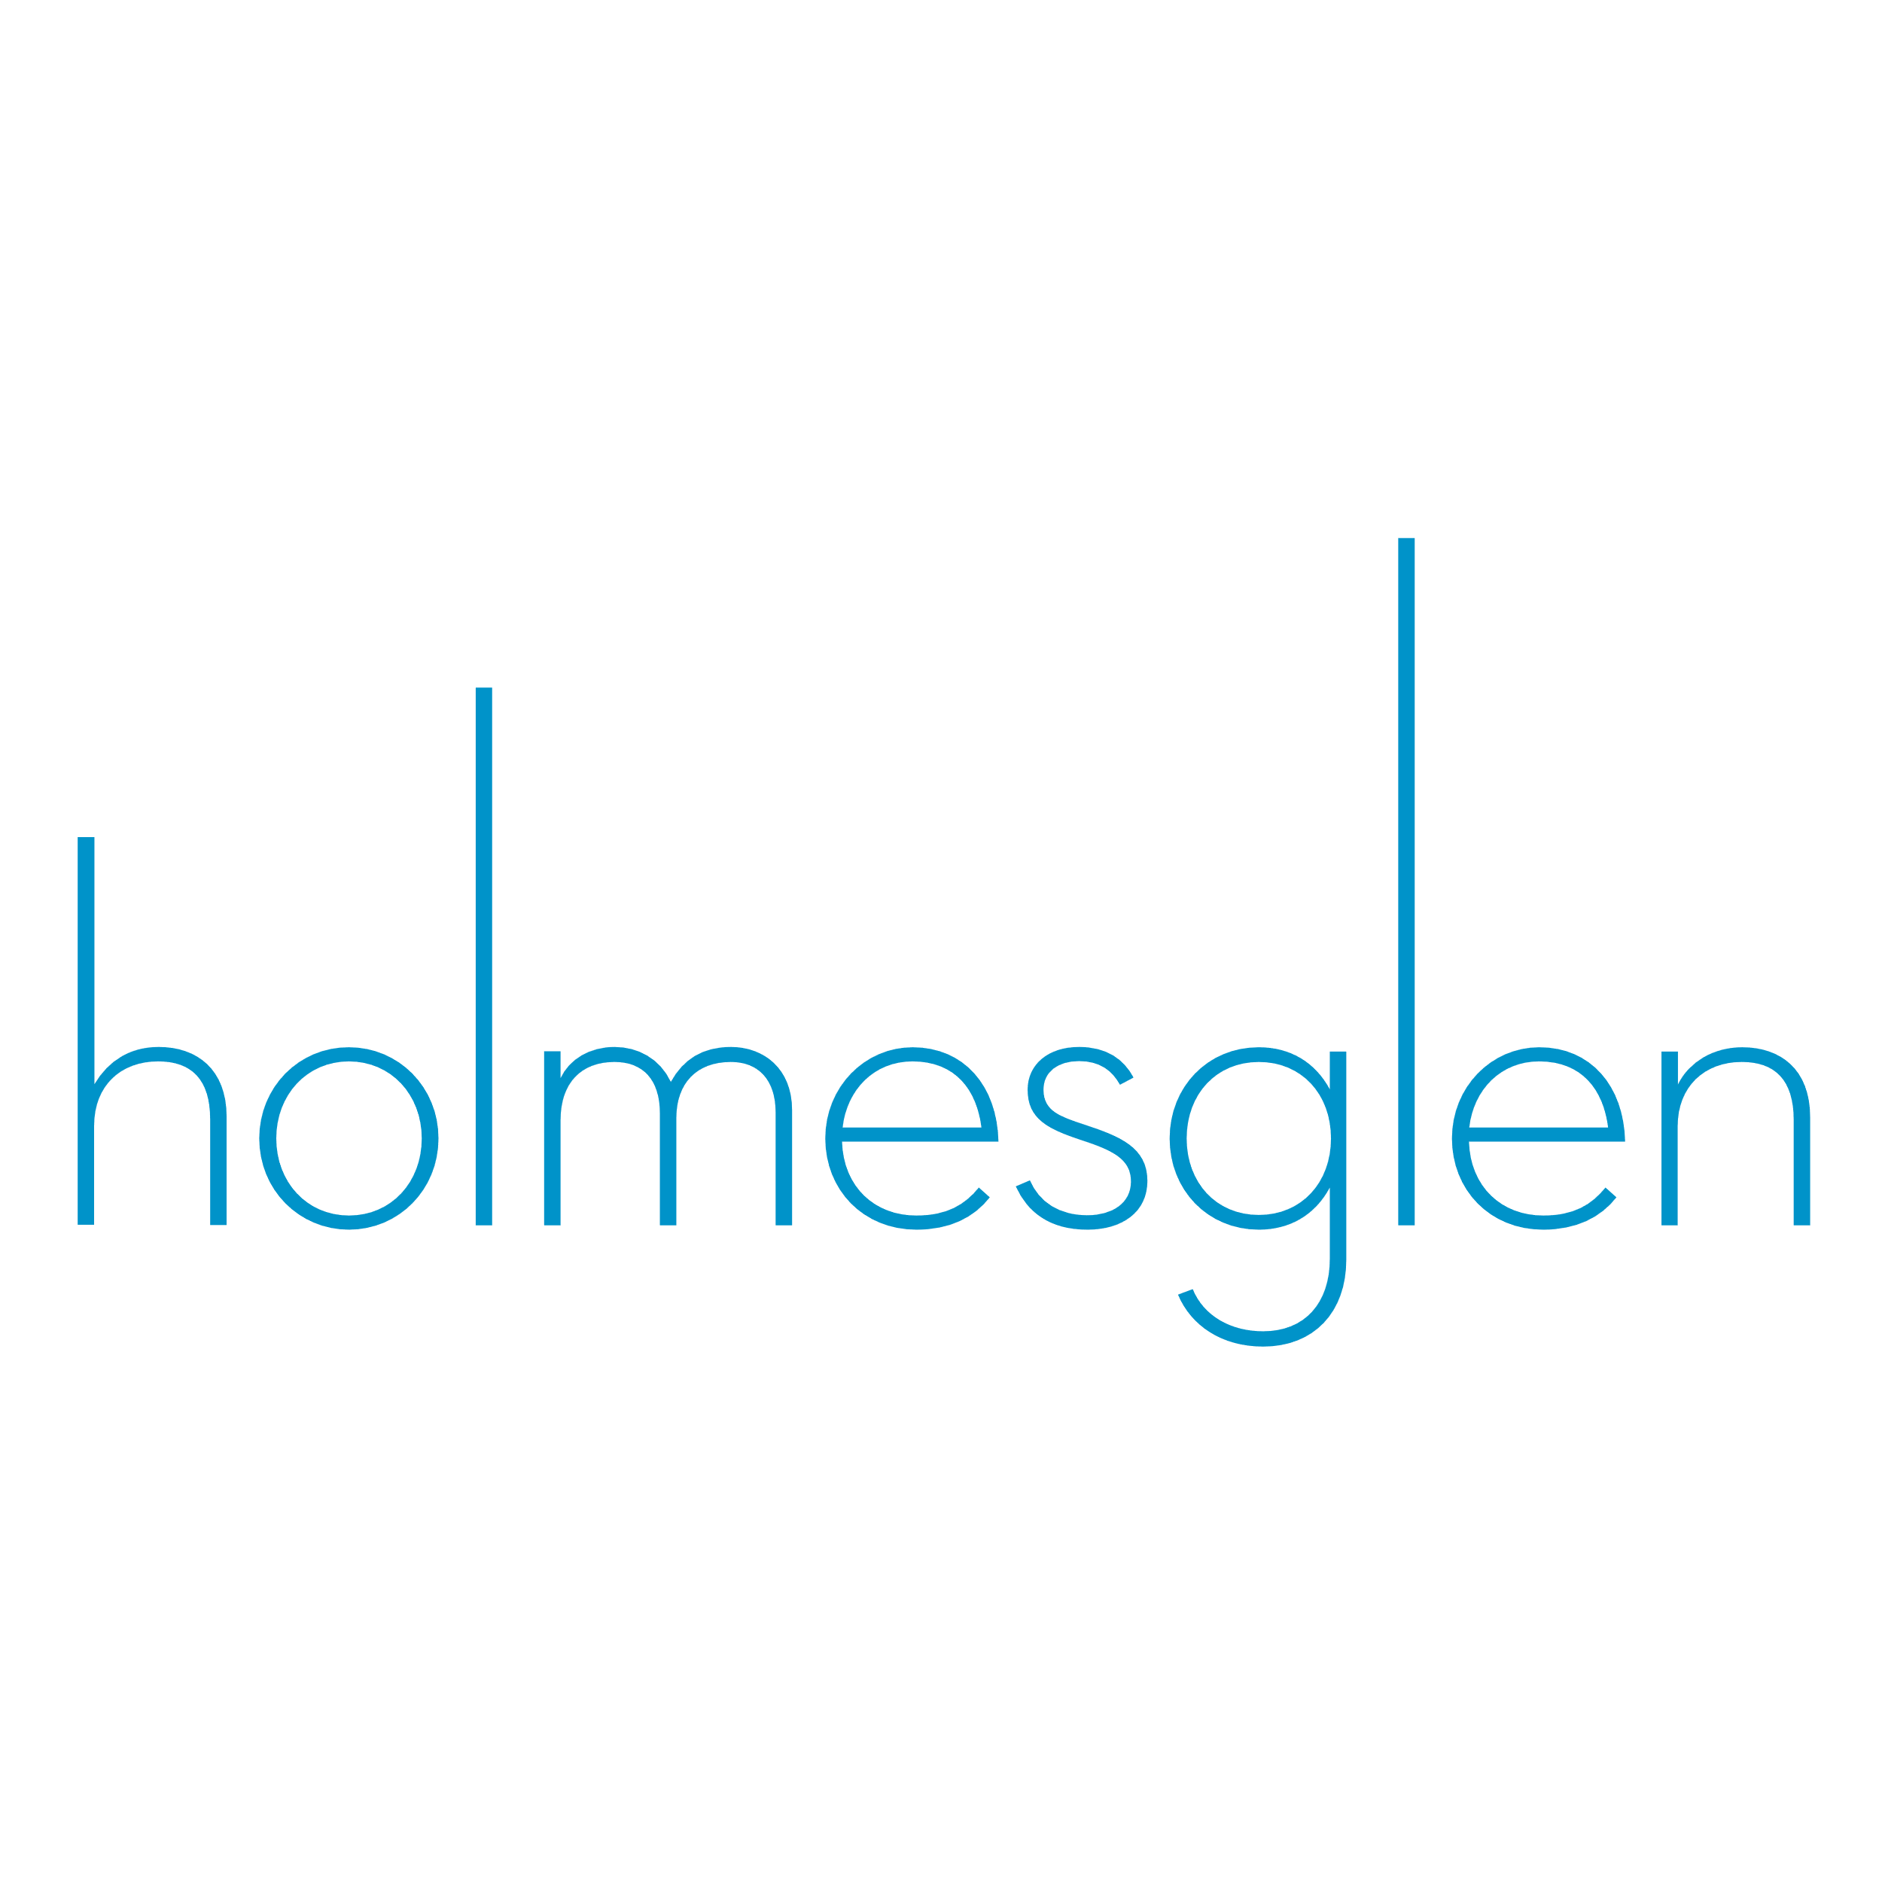

MOTIONWEB STUDIOS MAINTENACE REPORT
05/2025
MOTIONWEB STUDIOS MAINTENACE REPORT
A. ABOUT 3
B. OVERVIEW 3
1. Information 3
a. Project Name 3
b. Client Name 3
c. Project Team 3
d. Date 3
2. Technical Maintenance 3
a. Issues. 3
b. Solutions 4
c. Tasks 4
3. Content Analysis 4
a. Content Review 4
b. Updated or Edited Content 4
c. Added Content 5
d. Removed content 14
e. Plans for updating content 14

MAINTENANCE REPORT

ABOUT
Usage
This form is part of Motionweb Studios maintenance process, which Motionweb Studios project coordinators are expected to submit to the Governance Team before their maintenance meetings with them. More information about maintenance and best practices is available on the Motionweb Studios intranet.

OVERVIEW

Information

Project Name
- Motionweb Studios Maintenance.

Client Name
- Motionweb Studios.

Project Team
- Van Minh Le: Web Designer & Developer
- Luke Pham: Mentor / Assessor

Date
- 14/05/2025

Technical Maintenance

Issues.
- The previous designs are outdated, no longer meet modern and usability standards.
- Old design uses offline design tools like Photoshop and Illustrator, which made it difficult to collaborate and keep consistency with styling. It is very hard to receive feedback during the development process.
- There was no shared asset system, which led to inconsistent use of colours, typography, and layout styles across different pages.
- Clients or mentors could only review static files such as JPG or PDF. It made it hard to demonstrate user interactions or navigation flow.

Solutions
- The team design maintenance the website for EVORIDE with a more modern, improving the user experience.
- Figma is the main design platform. It allows for real time collaboration and easy sharing with mentors and team members.
- Build a shared component and style library in Figma to maintain consistency across the project.
- Use prototyping features in Figma to animate designs and make them interactive
- Use online sharing features in Figma to give clients ability to comment and make requests on designs

Tasks
- Identify and document the key design issues and inefficiencies in the previous workflow.
- Update the project database with proposed solutions and actionable tasks.
- Create a new sitemap and wireframes for the EVORIDE website, covering all four main pages: Homepage, Vehicles, Contact Us, and About Us.
- Develop updated designs in Figma according to the project brief and technical specifications.
- Set up a shared asset system in Figma to ensure consistency in colour schemes, typography, icons, and UI components across all pages.
- Use Figma’s prototyping tools to build an interactive version of the website, demonstrating user navigation and key interface interactions.
- Assign tasks where needed and inform the teacher (acting as Lead Developer) of project progress.
- Share the design prototype with the teacher for review, gather feedback, and apply necessary improvements.

Content Analysis

Content Review
- Current available content includes mood board, wireframes, concepts, and logo ideas
- File formats: .jpg, .png, .psd, and .ai
- Graphics quality is low resolution; many images require conversion to scalable vector format

Updated or Edited Content
- No updated legacy content reused in this version

Added Content
- Project concept developed for EVORIDE – a platform selling new and used vehicles

Homepage (Landing Page):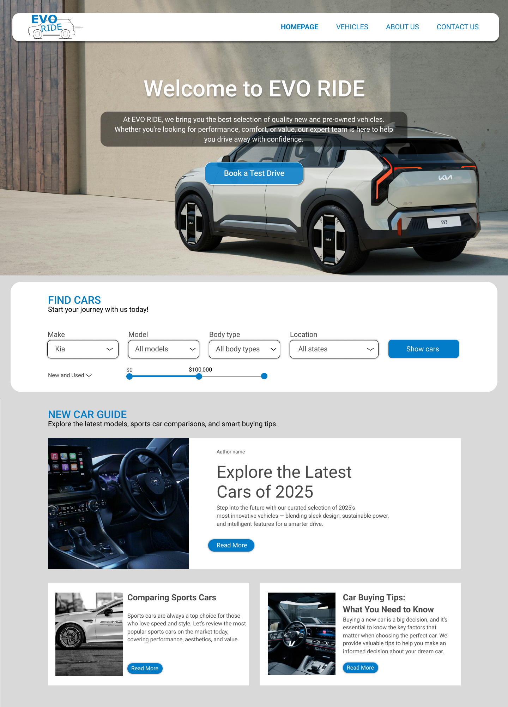
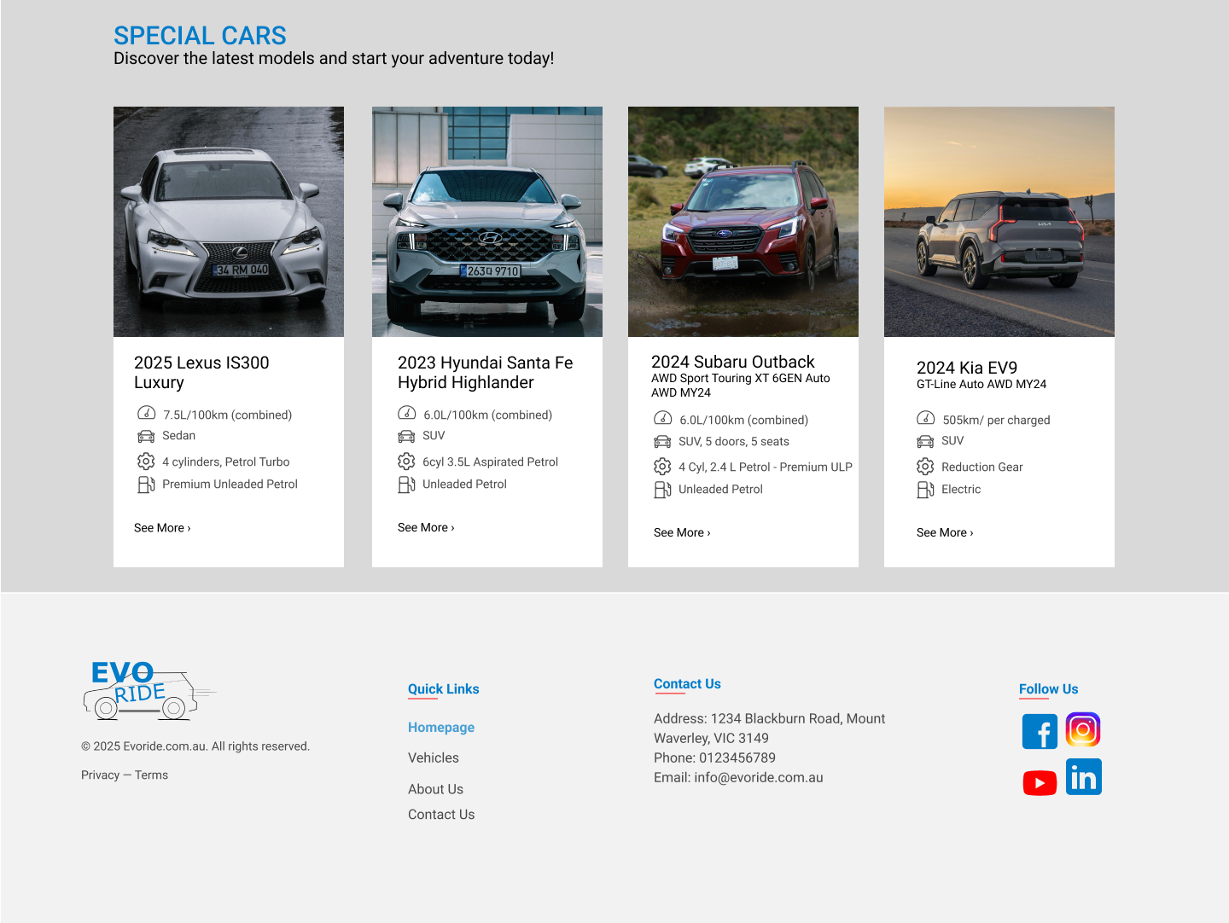

- Vehicle Page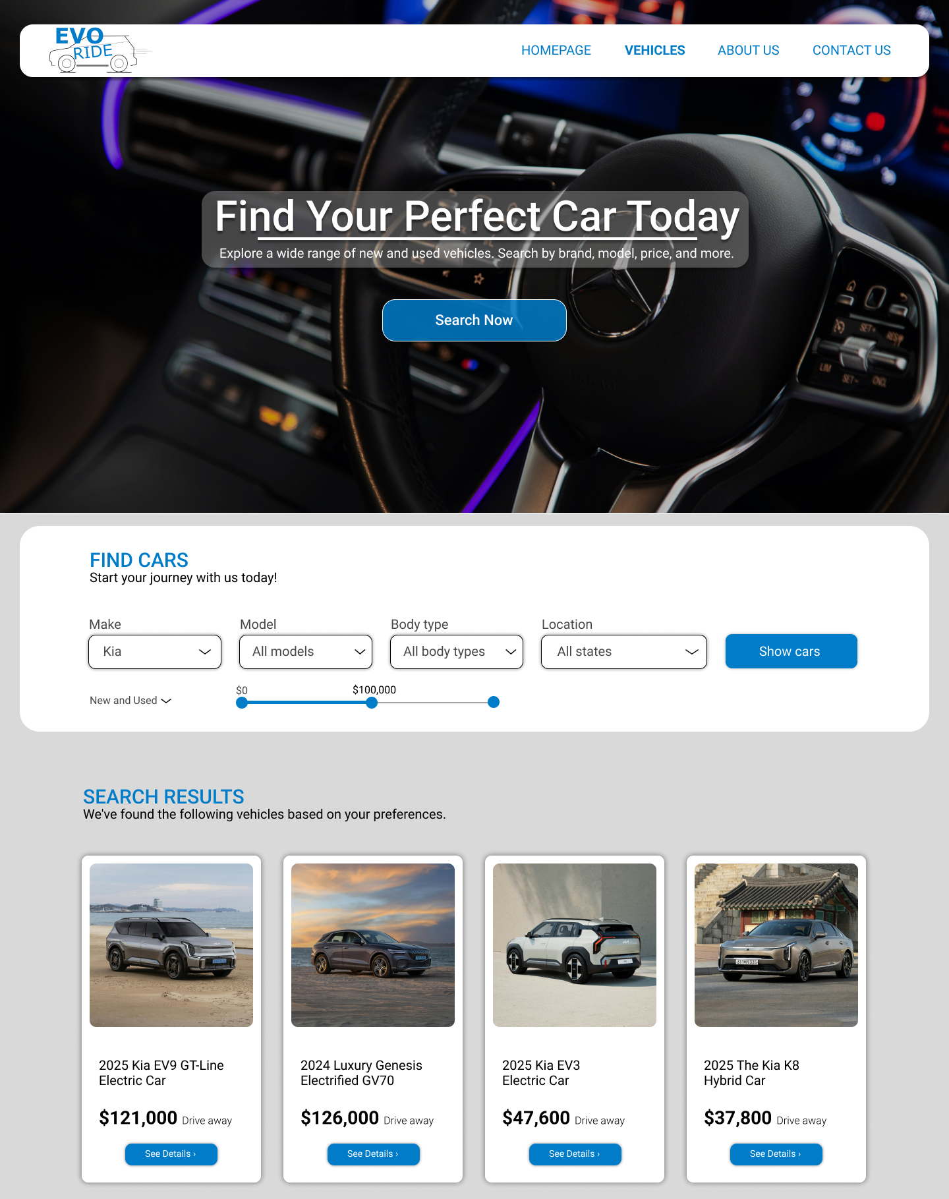

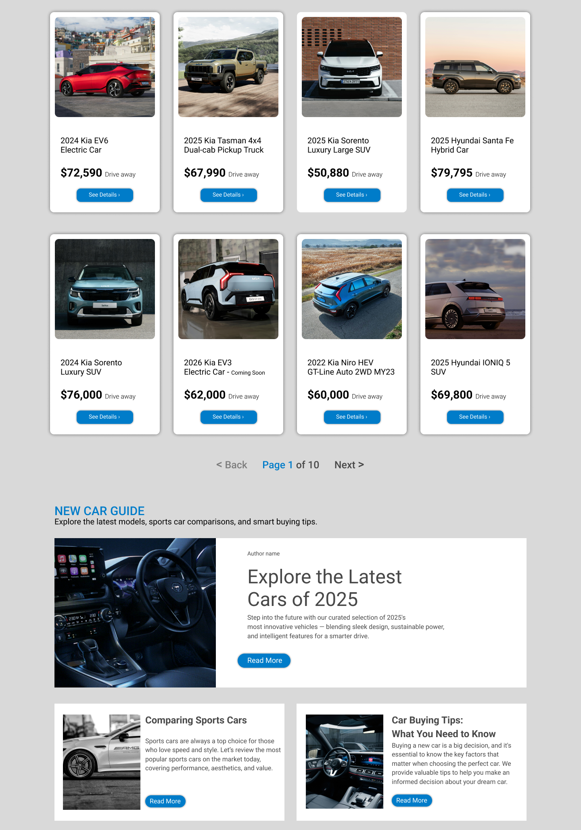
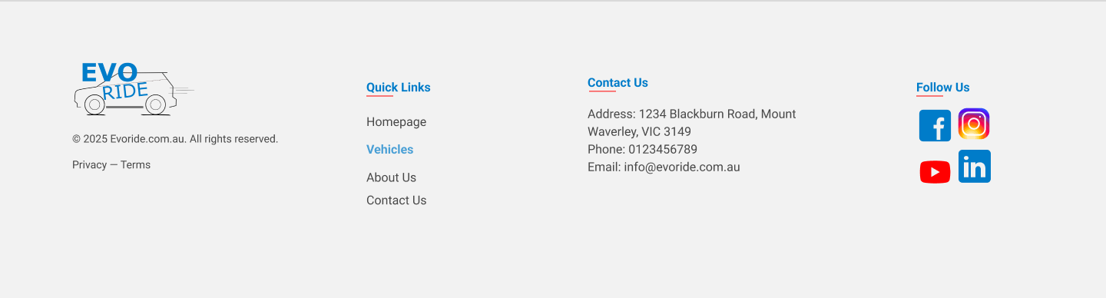

- About Us Page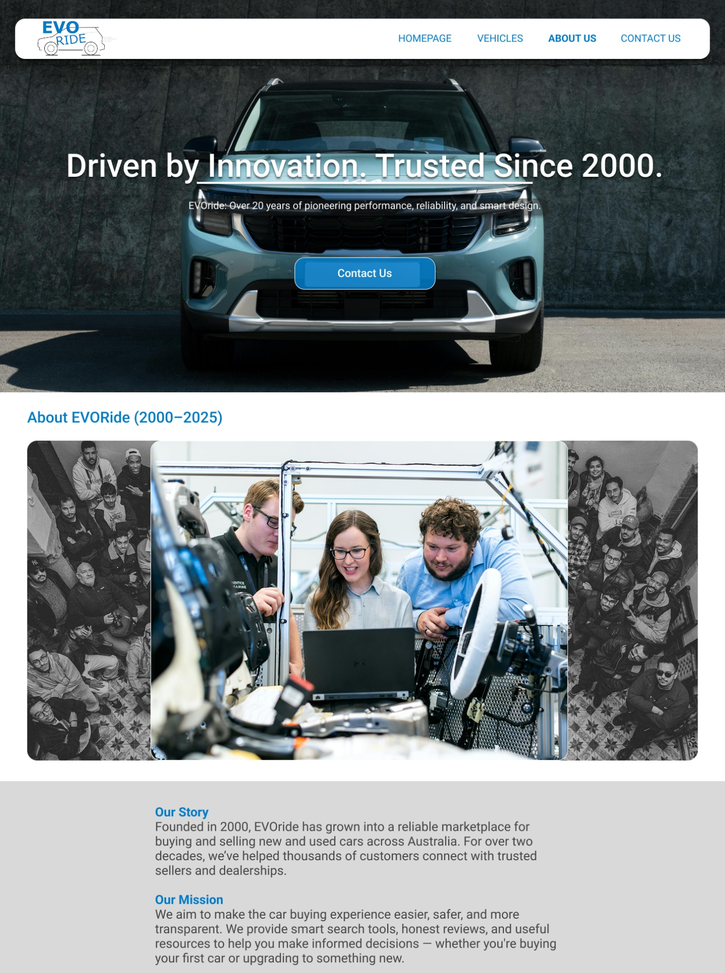
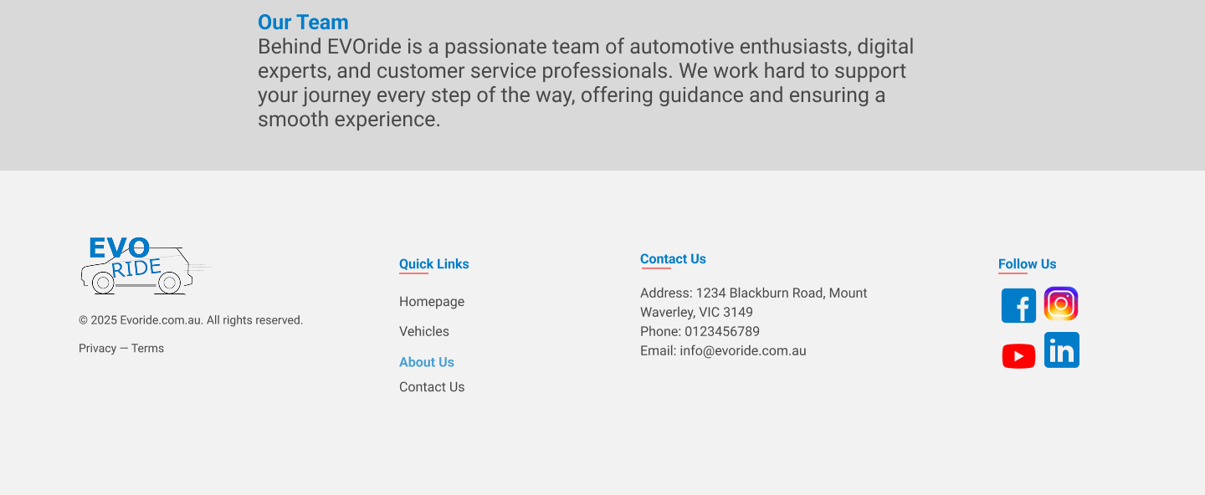

- Contact Us Page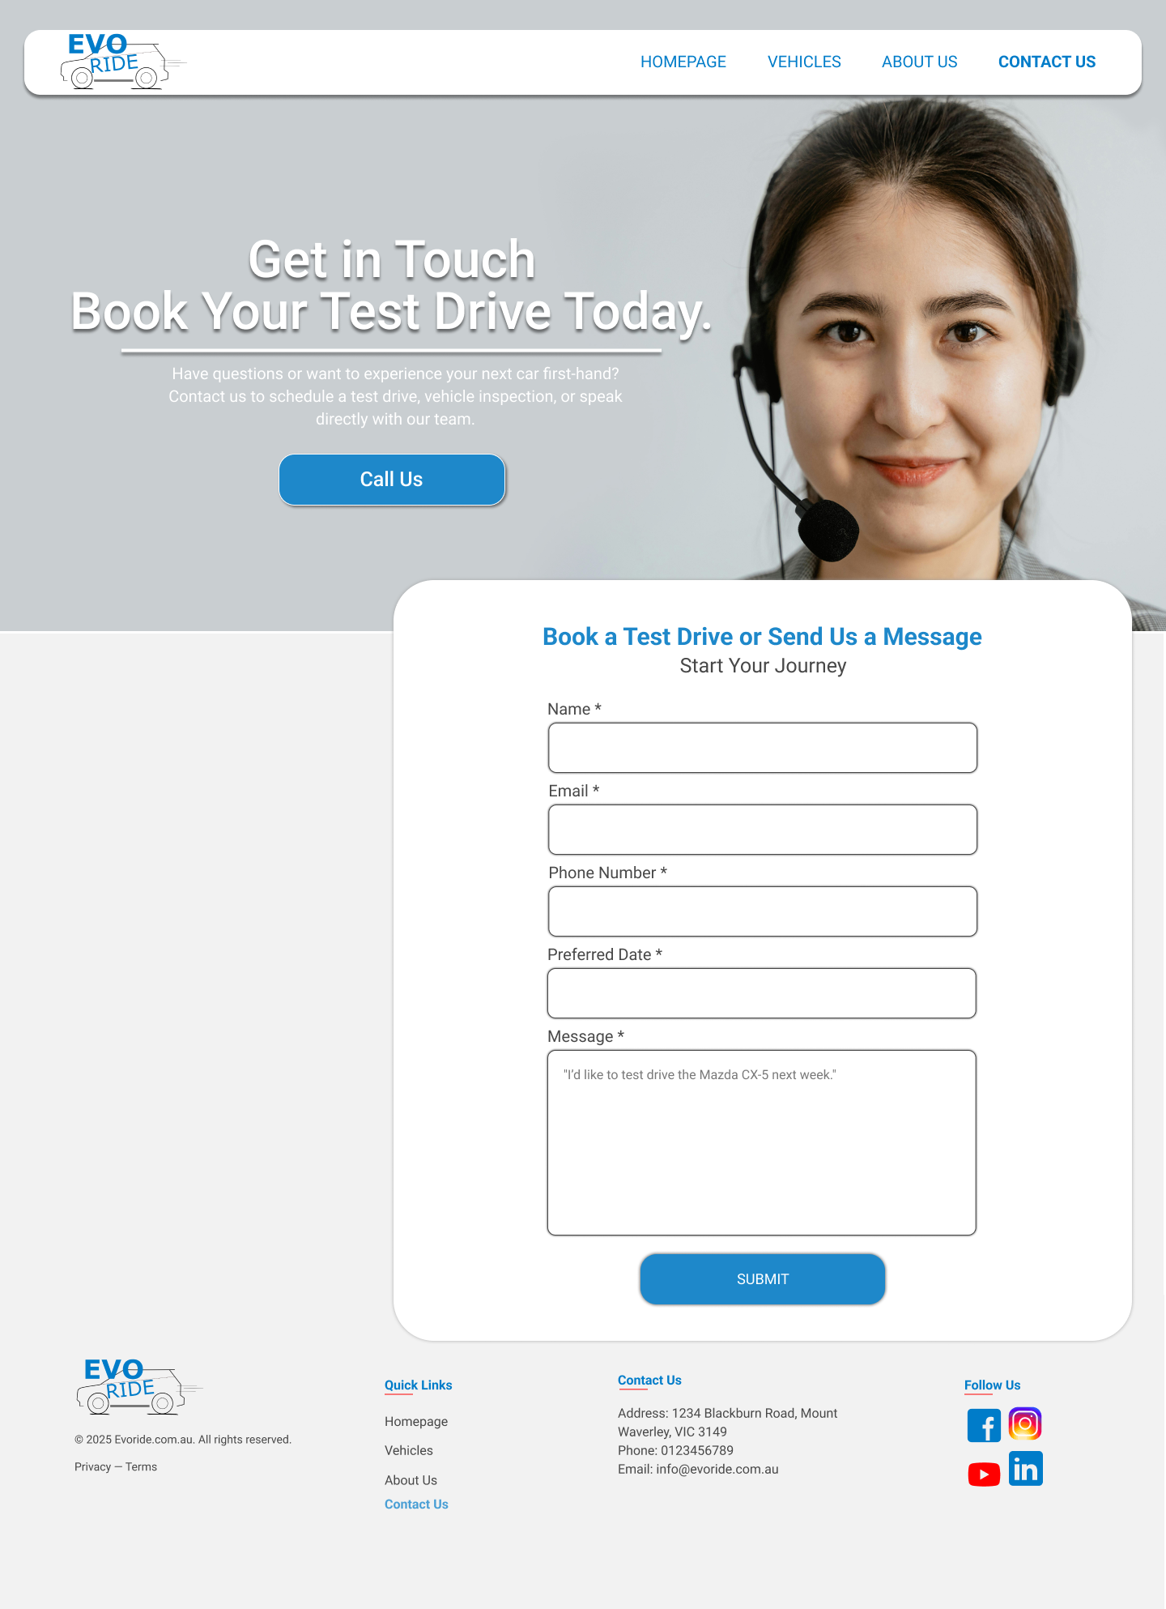

EVORIDE logo
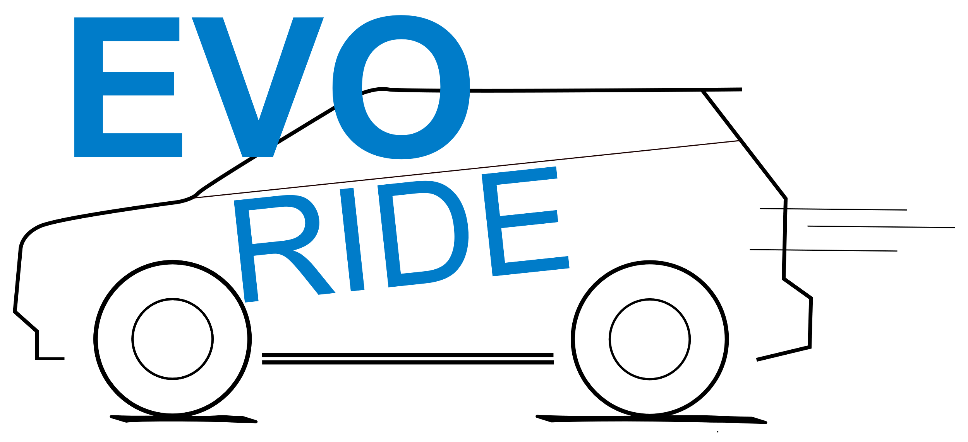

Removed content
- Removed all previous content

Plans for updating content
- Need to add additional variation to designs
- Need to add different styling options for logos

